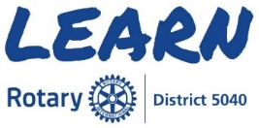
District Leaders
The Learning Center within My Rotary contains courses that enable
Rotarians to learn at anytime from anywhere.

You will need a My Rotary account to access the Learning Center
Rotary.org/My Rotary/Learning & Reference/Learning Center/
Rotary Courses - English

District Governor/Elect/Designate/Nominee
District Governor Basics – Learning Plan
District Governor Intermediate – Learning Plan
District Governor Advanced – Learning Plan
Assistant Governor
Assistant Governor Basics - Learning Plan
Council on Legislation Representative
Representative Training for Council
How to propose Enactments and Resolutions

Please note the above are only a few of the courses available and new courses
are being added regularly. We encourage you to explore the Learning Center
and broaden your knowledge of Rotary to enhance & increase our impact.

