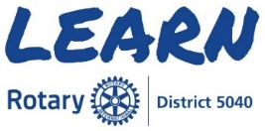
Club Level - Executive
The Learning Center within My Rotary contains courses that enable
Rotarians to learn at anytime from anywhere.

You will need a My Rotary account to access the Learning Center
Rotary.org/My Rotary/Learning & Reference/Learning Center/
Rotary Courses - English

- Club President/President Elect
    - Club President Basics - Learning Plan
- Club Secretary
    - Club Secretary Basics - Learning Plan
- Club Treasurer
    - Club Treasurer Basics - Learning Plan

Suggested for all Club Executive positions
- Club Administration Committee Basics – Learning Plan
- Practicing Flexibility and Innovation
- Building a Diverse Club
- Essentials of Understanding Conflict
- Leading Change

Please note the above are only a few of the courses available and new courses
are being added regularly. We encourage you to explore the Learning Center
and broaden your knowledge of Rotary to enhance & increase our impact.

